Event/Activity Name | Volley-ball Tournament
Dept. Name | All Department
Date of Event/Activity | 23/08/2025 to 29/08/2025
Time of Event/Activity | 10:30 AM
Event purpose/motive | The primary objective of the Volleyball Tournament was to provide students with a platform to learn, showcase, and enhance values such as teamwork, respect, and sportsmanship. The event also aimed to encourage physical fitness, foster camaraderie among participants, and develop leadership skills through active participation in this popular international sport.
No. of Participants | 112 players (across 14 team)
Location | GMIU Sports ground (behind dome area)
Expert details (if any) | NA
Brief About Event/Activity | The Volleyball Tournament held on 23 August 2025 to 29 August 2025 was a spectacular and energizing event that witnessed remarkable participation from students across all departments, with 14 enthusiastic teams competing for the championship title. This thrilling competition featured intense robin round matches, where all 14 teams battled fiercely to secure their positions. The atmosphere was electric as players demonstrated exceptional serving techniques, powerful spikes, strategic blocks, and seamless teamwork. After rigorous robin round competition, three outstanding teams emerged to compete in the semi-finals: The Boys, Flying Falcons, and Volley Strikers. The semi-final stage proved to be a true test of endurance and skill. Through closely contested matches filled with dramatic rallies and spectacular saves, The Boys and Flying Falcons showcased superior coordination and tactical brilliance, earning their spots in the grand finale. Both teams displayed remarkable sportsmanship and competitive spirit throughout their journey. The championship final between The Boys and Flying Falcons was an absolute masterpiece of volleyball artistry. In a thrilling encounter that kept spectators on the edge of their seats, Flying Falcons demonstrated exceptional teamwork, precision, and mental fortitude, ultimately triumphing with a commanding 3-0 victory. The tournament concluded with tremendous celebration and appreciation for all participants.  Congratulations to Flying Falcons for their magnificent championship victory!
Event/Activity Coordinator Name | Coach: Mehta Tulsi  Prof. Dr. Kishor Anjara
Winner Team | FLYING FALCONS
Runners-Up Team | THE BOYS
Photograph:
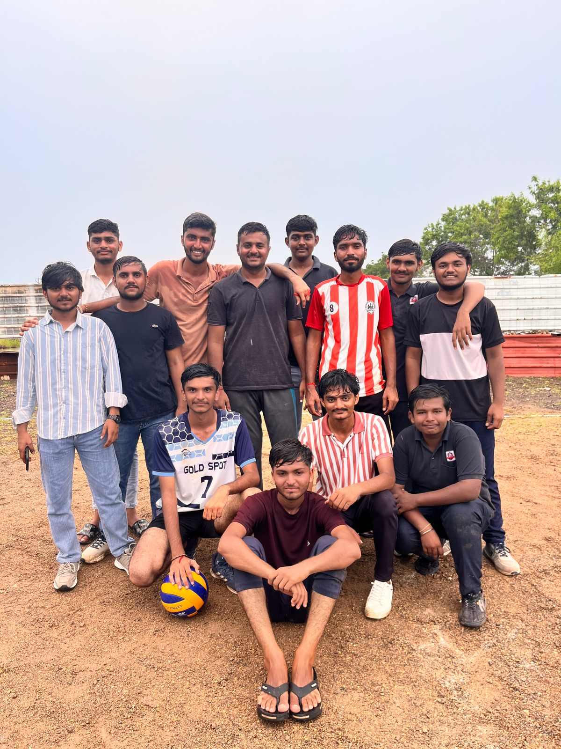

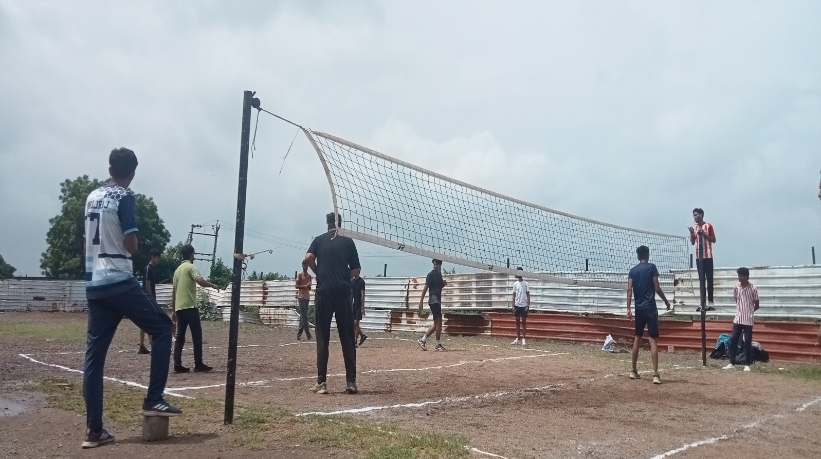
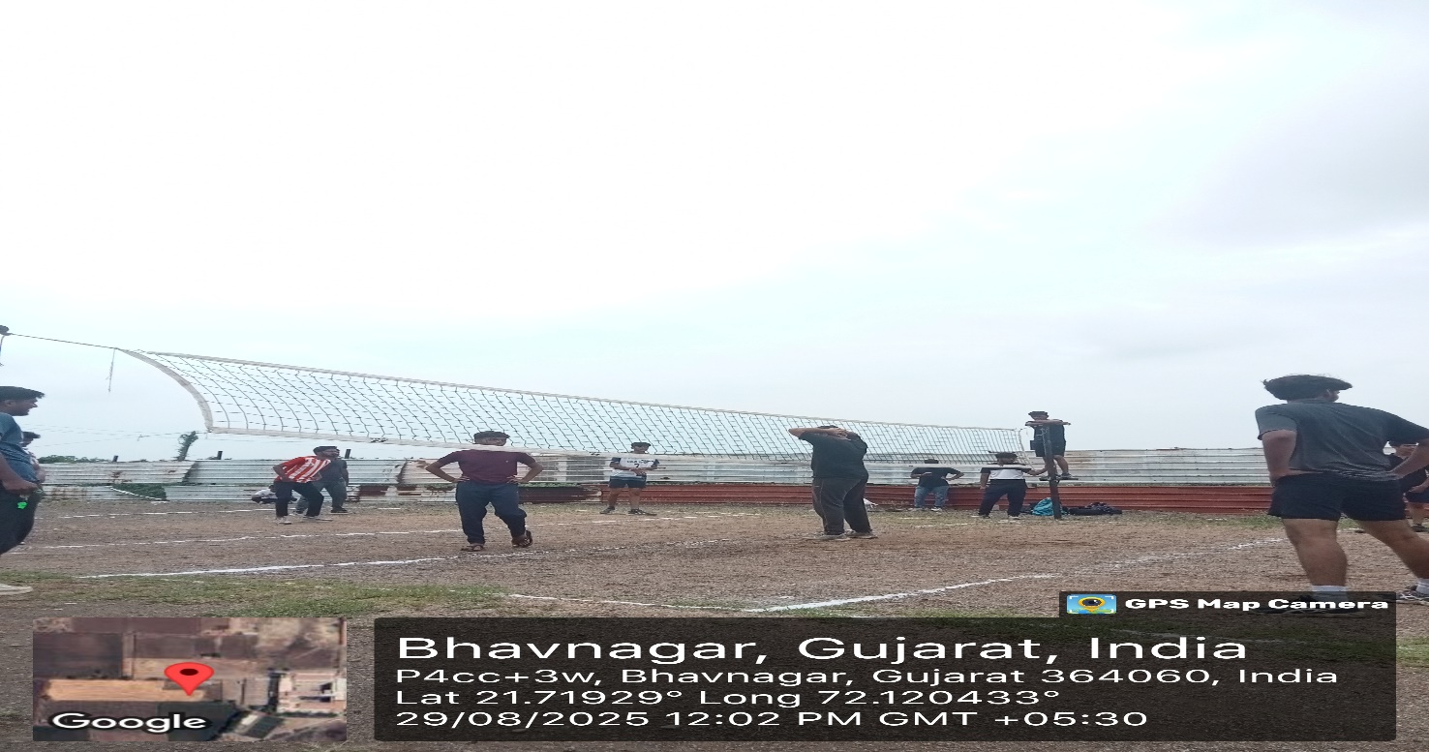

Remarks:
- The tournament was an exceptional demonstration of athletic prowess, strategic thinking, and team coordination.
- Participants displayed remarkable sportsmanship, with intense competition balanced by mutual respect and fair play.

- Faculty members and spectators commended the excellent organization and the high level of skill demonstrated by all teams.
- This event successfully promoted volleyball as a sport that combines physical fitness with mental strategy, encouraging students to pursue athletic excellence.
- The tournament reinforced the importance of regular physical activity and competitive sports in overall student development.

Event/Activity feedbacks by faculty or students (if have any) - NA
Note: Event/Activity forms must be submitted within 2 days with Canva post/Reel. (Soft copy-word)

